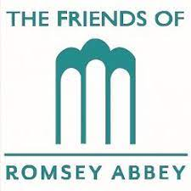

The Friends of Romsey Abbey
Charity Number 1134191

2023 ANNUAL GENERAL MEETING

Sunday 11th June 2023 in The Church Rooms at 4.30pm

AGENDA

- Opening Prayer

- Welcome by the President

- Apologies

- Minutes of the last meeting

- Chairman’s Report

- Honorary Treasurer’s Report

- Honorary Project Chairman’s Report

- Honorary Events Chairman’s Report

- Honorary Membership Secretary’s Report

10. Election of Officers and Committee Members

11. Any Other Business

