A message from our Chair, Jill Hall
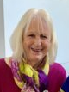
A warm welcome to you all to our Summer Newsletter. We have much to reflect on since our previous newsletter both on our projects work as well as the busy Events calendar. Many will have enjoyed the social occasions and there are more to look forward to. The Boat Trip has been rescheduled for 23 August and sadly, there has been insufficient support for the Annual Dinner to make it viable, so we will be reviewing options on that at our next Committee meeting. Hopefully we can find an alternative opportunity for Friends to meet socially over a meal.

We are delighted to welcome Chris Harpham, Head Verger, to our meetings, particularly because Chris was part of the original committee when the Friends was founded. We also look forward to seeing Jan Bartlett joining us for our meetings as she now replaces Julie Carlton who gave us so much help and support during her time as a Church Warden.

We are grateful to the late Sandra Vines who kindly left the Friends of Romsey Abbey a small legacy in her will which her son has distributed. There are no conditions of use but it will undoubtedly be utilised wisely and to good effect.

Thank you all for your support. If you don’t already join us for a Coffee Morning, do please give it a try and as those events are open to Non-Members as well as Members, do by all means bring a friend along – who knows, they might like to become a ‘Friend’!

I look forward to seeing many of you at future events and do make contact with us if you have any queries or questions – office@romseyabbeyfriends.org

PROJECTS
Whilst making progress on a project is not always straightforward, we are happy to inform you that there have been some good strides made on those planned as well as some that weren’t perhaps on our list.

Toys and Play equipment

We received a request for new toys and play equipment for just under £2,500 to improve the offering for the youngsters in our orbit. The existing toys and equipment were old and worn. A rush of emails secured agreement from the Committee to fund this, and we were delighted to learn that the new equipment has proved a massive hit. It is in use for different children’s groups including Singing Story Time and the Toddler Group as well as the Oasis group and Little Angels. It can also be used for youth groups as well as for pop up events.

External Rood
Earlier this year the Friends employed a world-class company in the field of non-destructive testing of masonry and concrete building structures to examine the Romsey Rood. They employed a wide range of techniques to explore the structure of the Rood and its condition. They also produced for us, for the first time, a high-definition photograph of the Rood.
The Rood is comprised of three carved oolitic limestone blocks: a vertical block for the body and a horizontal block for each arm. Additionally, beneath the feet is a corbel. Impulse radar scanning has revealed that the depth of stone beneath the carving varies between 125mm and 150mm (5 and 6 inches) and that the bonding between the Rood stones and the wall behind is very poor.
The canopy, originally erected over the Rood in 1897, has done a reasonably good job of preserving the upper parts of the statue (torso upwards), which were assessed to be relatively stable although soft. However, the legs, feet and corbel are decaying more rapidly and exhibiting surface-level delamination. A micro-climate has developed immediately under the canopy which favours the growth of algae on the masonry. It is quite extensive and there is now some algal growth on the Rood stone itself on either side of the hand of God.
The full report and photo have been forwarded to the PCC’s Fabric Committee for use by future stone conservators. Hopefully, this additional information will contribute towards finding the best way of conserving the Rood for future generations.
Abbey Signage

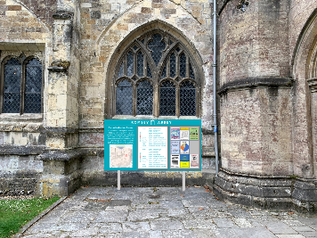
The Vicar would like to replace the current motley collection of out-of-date signage and
difficult-to-use notice boards with an integrated set displaying helpful, up-to-date information at the right places in a modern consistent style. The Friends have agreed to cover the total cost. We were involved in selecting a design partner for the project and identifying appropriate locations. The design, wording and locations have all now been agreed and approvals are currently being sought.

(Please note, the graphic is not representative of either final design or location)

St Swithun’s vestry refurbishment
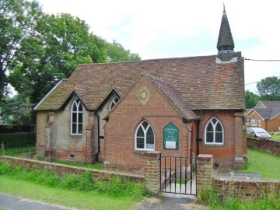
The Friends have been working with the St Swithun’s Committee Chairman to produce a plan to refurbish the vestry to make it a safer, more comfortable and welcoming room, particularly for outreach activities aimed at young families from nearby housing estates. Together, we decided that the best way of achieving this was to have a run of fitted cupboards all along the north wall, with interiors customised to hold all items required by the various users of the room. Initial ideas have been obtained and the design is currently being refined. With the new cupboards in place, the floor covering will be replaced.
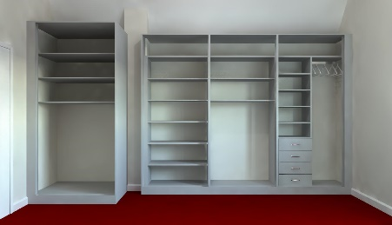
Inevitably, when you start refurbishing one part of building, it follows that there are additional facilities which require attention. In this instance, covering the north wall with cupboards requires that heating is moved to the south wall and the opportunity is being taken to provide a second light switch at the entrance from the kitchenette. Heat insulation is to be provided in the roof space and a patch of damp on the south wall near the external door is to be cured.
There is no doubt that this work will provide the quality of space and storage to make a much more cheerful and comfortable space for all users.

Stewards Lanyards
There had been some considerable discussion at a stewards’ get-together on something different/more substantial than the current lanyards and badges. After much investigation, it transpired that other ecclesiastical establishments had reverted to lanyards as the available alternatives had proved to not be viable. The Friends agreed to fund an improvement as it will enhance the professional image of the stewards and to that end a printed plastic badge with a credit card size insert has been supplied with a fresh double sided lanyard.

THE SOCIAL SCENE

Obviously, it is not all about projects and work! There is a busy and varied Events programme which is progressing through the year. Most events are sold out but if you wish to join one, do email events@romseyabbeyfriends.org to see if there is a space available or to go on a waiting list. Spaces remain available on the theatre trip in December to The Mill at Sonning

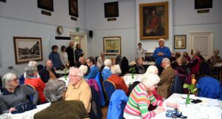
Coffee Mornings continue to be popular and amazingly good value at £2 for cafetiere coffee, home-made biscuits as well as the opportunity to take part in the raffle. If you haven’t tried it, do give it a go – a warm welcome and good company awaits.

Highclere Castle

Everyone knows that Downton Abbey is a fictional location, but of course it was filmed at Highclere Castle near Newbury, and the Friends of Romsey Abbey enjoyed a trip there on 28th May. In the room identified as the setting for Lord and Lady Grantham’s bedroom, it was noted that apart from the actors, about 30 crew had to be accommodated during filming; it must have been a very tight squeeze!
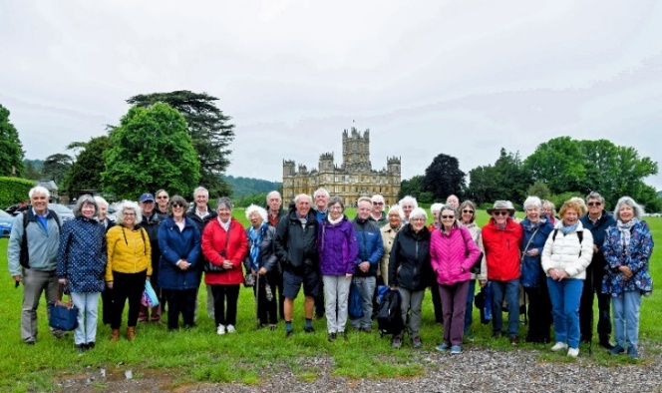
Highclere is also the real-life home of Lord and Lady Caernarvon. The 5th Lord Caernarvon was well-known in the early 20th Century for having funded the archaeological expeditions to Egypt conducted with Howard Carter. The cellars of the castle hold the fascinating exhibition about the expeditions which was extremely well presented.

Desert Island Discs

On 3 June, an audience of around 200 gathered in Romsey Abbey to enjoy Bryan Taphouse as the guest on Desert Island Discs, an event organised by the Friends of Romsey Abbey and hosted by Dick Hewett.
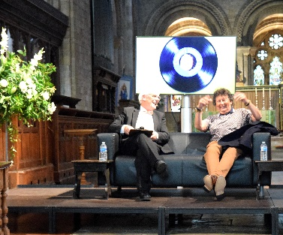
By chance, the date was the occasion of Bryan’s 74th birthday. He was born and grew up in Bath. Whilst he admitted to not being a great academic at school, he did excel at sport. His initial and unsuccessful debut into the world of work was in an architect’s practice where he was not delighted at being used as an office boy so he moved into clothes retailing ultimately working for Austin Reed. He was also a drummer in a band.
On New Year’s Eve 1972/3 he met Jackie and the next day they agreed to marry which they did in September of 1973.
In 1976 Bryan was selling fabric and in the 1990s he started his own business selling skirts, subsequently setting up a new company in 2013 which is run by the family.
Bryan and Jackie were encouraged to start a house group by the head of Romsey Abbey Primary School and that began their long association with the Abbey. Brian was ordained in 1998.
Despite health set backs, Bryan has continued to live his life to the full having been President of Rotary three times and was the prime mover in starting ‘Carols in the Square’.
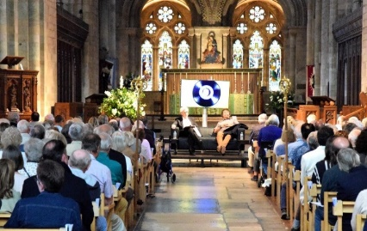
The music chosen by Bryan ranged across ‘Smile’ by Nat King Cole, John Lennon’s ‘In my life’, to Ed Sheeran’s ‘The Joker and the Queen’ as well as Cold Play’s version of ‘Viva la Vida’. When questioned, Bryan revealed that he felt his greatest achievement was having the opportunity to make a difference in the lives of others, reflected in the song ‘That’s what friends are for’.
Apart from the Bible and the Complete Works of Shakespeare, Bryan selected Bear Grylls’ Survival Guide to take to his desert island and confirmed ‘Smile’ as his favourite music. His one luxury was a photo album with pictures of family and friends.
The evening was rounded off by the presentation by Liz Wagner of a birthday cake for Bryan, complete with candles, which was shared amongst the audience.

‘Full steam ahead’ on the Isle of Wight
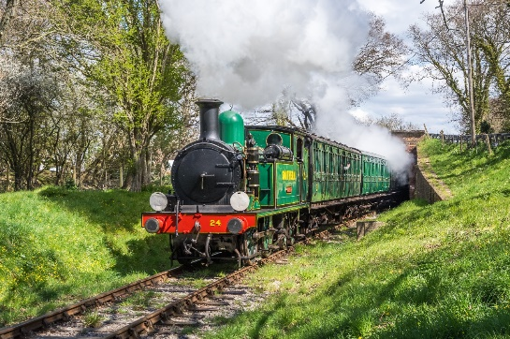
This was the day when a group of the Friends of Romsey Abbey achieved travel by three different means – minibus, boat (ferry) and steam train. Blue sky, a calm sea, and steam up – what more could anyone want for a trip to the Isle of Wight Steam Railway? Two full minibuses embarked on the Red Funnel ferry on 18th June for a day on the Island. There was plenty of time for everyone to wander around the site at Haven Street station, before boarding the train for a round trip to Wootton Bridge and Smallbrook Junction.
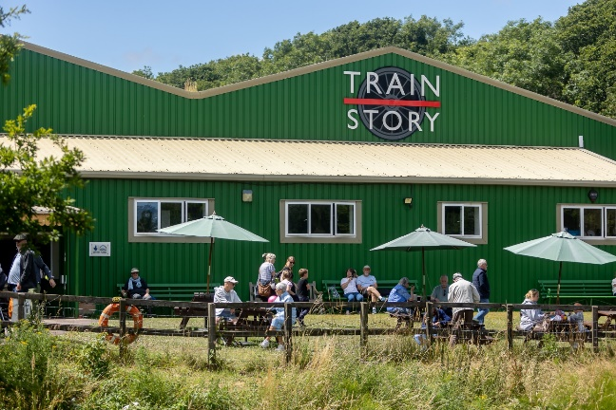
The railway is characterised by small railway coaches from the Victorian era which have been lovingly restored by volunteers from their most recent status as chicken shed, holiday caravans, and even bungalows in various locations around the island. The railways on the Isle of Wight were, and continue to be, the recipient of railway engines and carriages retired from the mainland, which gives it a uniquely historic feel. The Train Story Museum at Haven Street features a range of locos and stock from the past 100 years.
This was a popular trip (as steam railways invariably are) and everyone clearly enjoyed the day. Relaxing on the ferry back, there was time for a cuppa before arriving back at Romsey at exactly the forecast time.
Thanks to the Isle of Wight Steam Railway for their photos
Most other photos courtesy of Ken Gibson.
Our new website will soon be going live – we just have a few small details to sort and will let you all know when you can view it.
If you have any queries about the Friends of Romsey Abbey or would like to volunteer in any way, do please contact us at office@romseyabbeyfriends.org.

